**Assignment – III**

|  |  |
| --- | --- |
| Name | Abhay Deep |
| Team ID | PNT2022TMID14584 |
| Roll No | 7179KCTKCTKCTKCTKCTKCTKCT19BCS011 |
| Project Name | Customer Care Registry |

**1.Create a Bucket in IBM object storage.**

* **Created a IBM object storage bucket.**
* **Stored 5 css images**

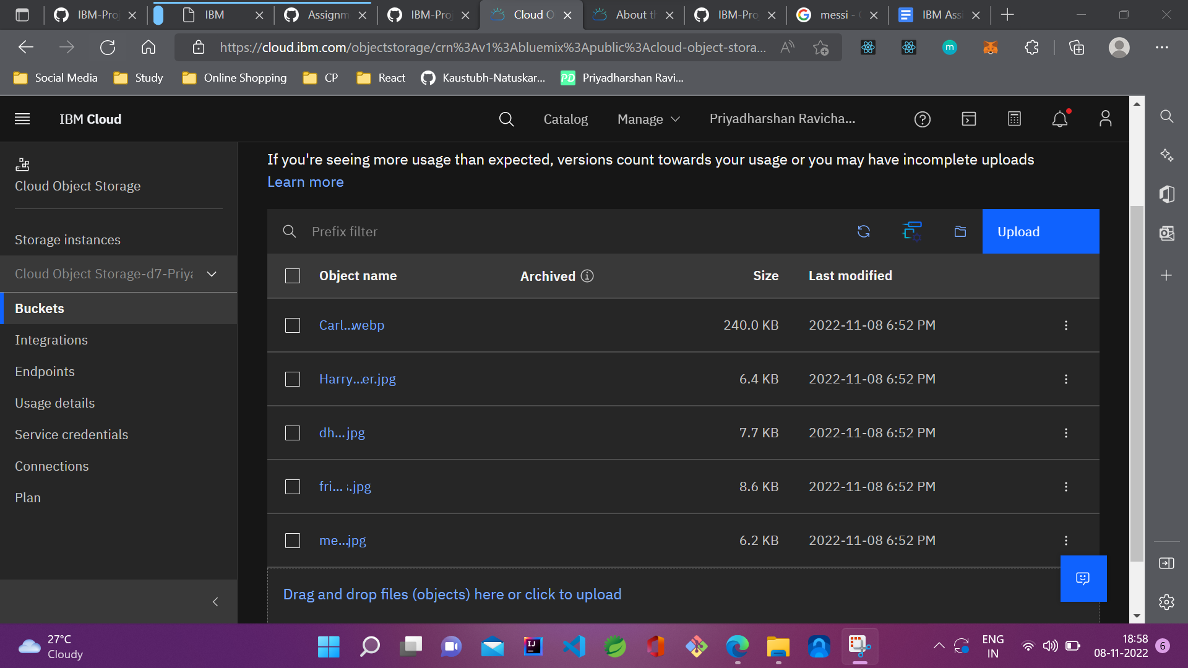

**2.Upload 5 images to ibm object storage and make it public. write html code to display all the 5 images.**

**index.html**

**<!DOCTYPE html>**

**<html lang="en">**

**<head>**

**<meta charset="UTF-8" />**

**<meta http-equiv="X-UA-Compatible" content="IE=edge" />**

**<meta name="viewport" content="width=device-width, initial-scale=1.0" />**

**<title>Document</title>**

**</head>**

**<body>**

**<div>Below are 5 images from ibm cloud storage bucket.</div>**

**<img**

**src="https://ibm-smart-internz-pntibmmv.s3.jp-tok.cloud-object-storage.appdomain.cloud/Carlsen.webp"**

**height="200px"**

**/>**

**<img**

**src="https://ibm-smart-internz-pntibmmv.s3.jp-tok.cloud-object-storage.appdomain.cloud/Harry-potter.jpg"**

**height="200px"**

**/>**

**<img**

**src="https://ibm-smart-internz-pntibmmv.s3.jp-tok.cloud-object-storage.appdomain.cloud/dhoni.jpg"**

**height="200px"**

**/>**

**<img**

**src="https://ibm-smart-internz-pntibmmv.s3.jp-tok.cloud-object-storage.appdomain.cloud/friends.jpg"**

**height="200px"**

**/>**

**<img**

**src="https://ibm-smart-internz-pntibmmv.s3.jp-tok.cloud-object-storage.appdomain.cloud/messi.jpg"**

**height="200px"**

**/>**

**</body>**

**</html>**

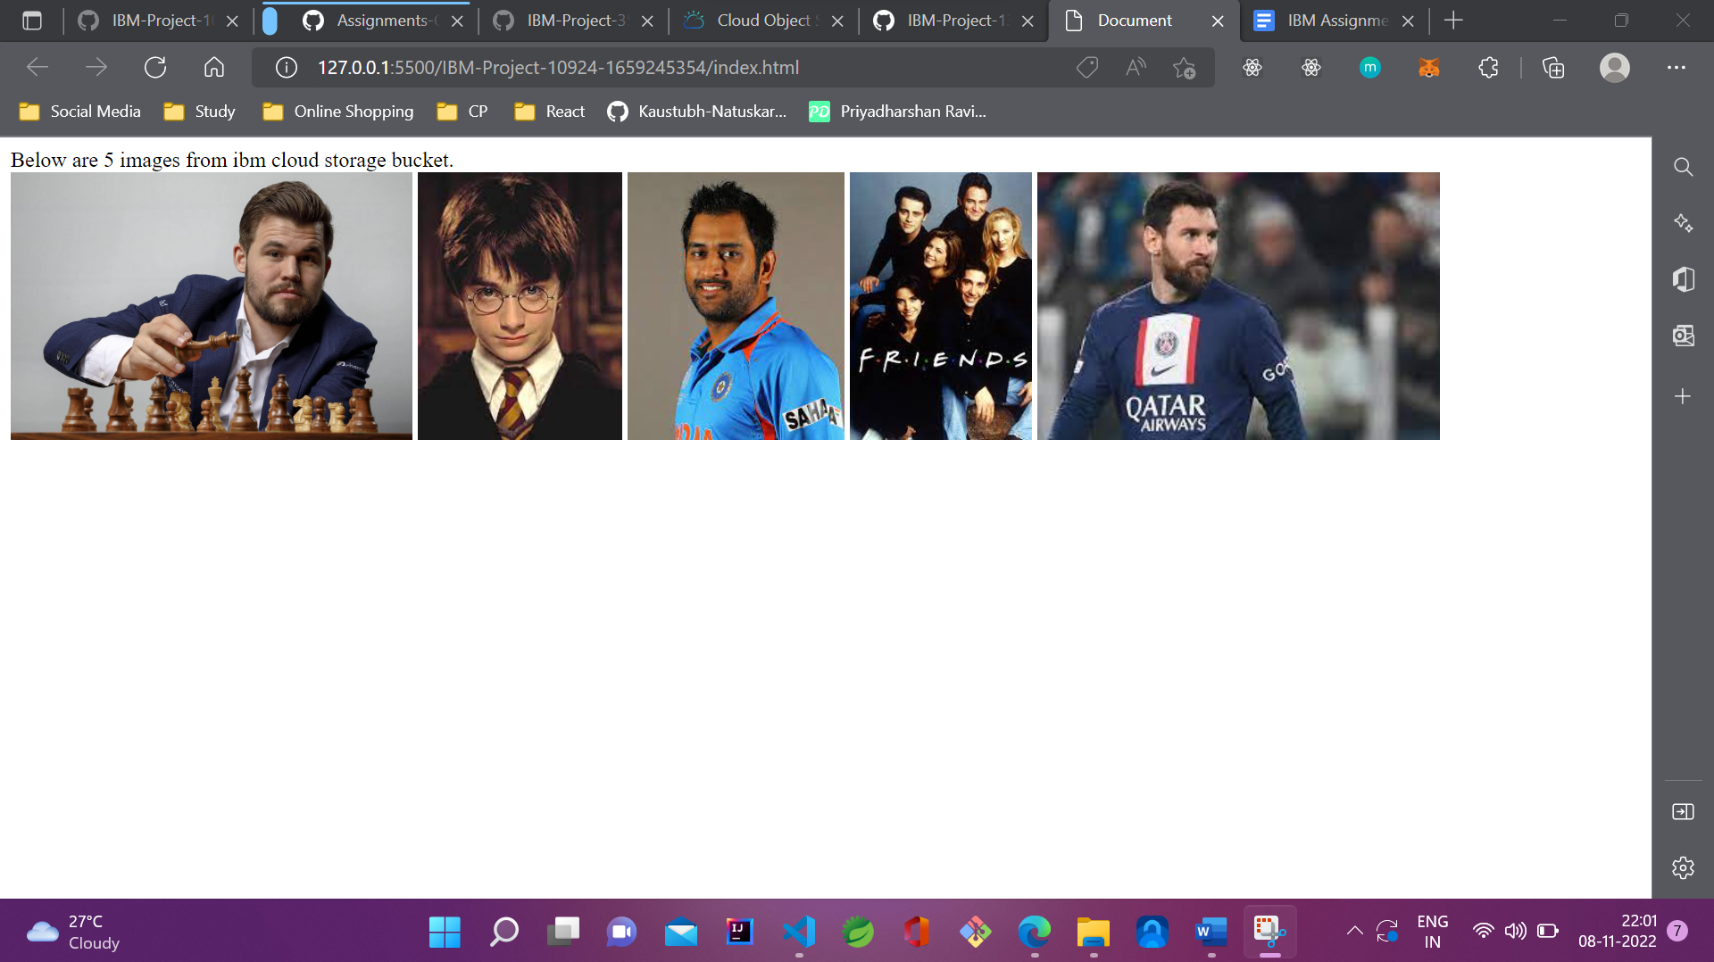

**3.Upload a css page to the object storage and use the same page in your HTML code.**

**style.css**

**.from-cloud-bg-box {**

**background-color: red;**

**padding: 5rem 10rem;**

**}**

**.from-cloud-text {**

**color: white;**

**}**

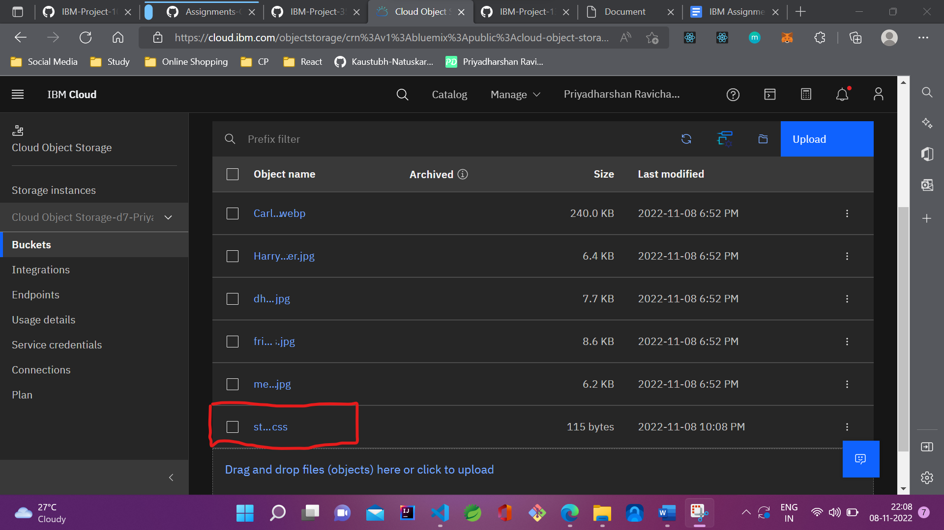

**index.html**

**<!DOCTYPE html>**

**<html lang="en">**

**<head>**

**<meta charset="UTF-8" />**

**<meta http-equiv="X-UA-Compatible" content="IE=edge" />**

**<meta name="viewport" content="width=device-width, initial-scale=1.0" />**

**<title>Document</title>**

**<link**

**rel="stylesheet"**

**type="text/css"**

**href="https://ibm-smart-internz-pntibmmv.s3.jp-tok.cloud-object-storage.appdomain.cloud/style.css"**

**/>**

**</head>**

**<body>**

**<div class="from-cloud-bg-box from-cloud-text">**

**The styles applied to this box are from cloud. We've imported them in the**

**head tag using link tag.**

**</div>**

**</body>**

**</html>**

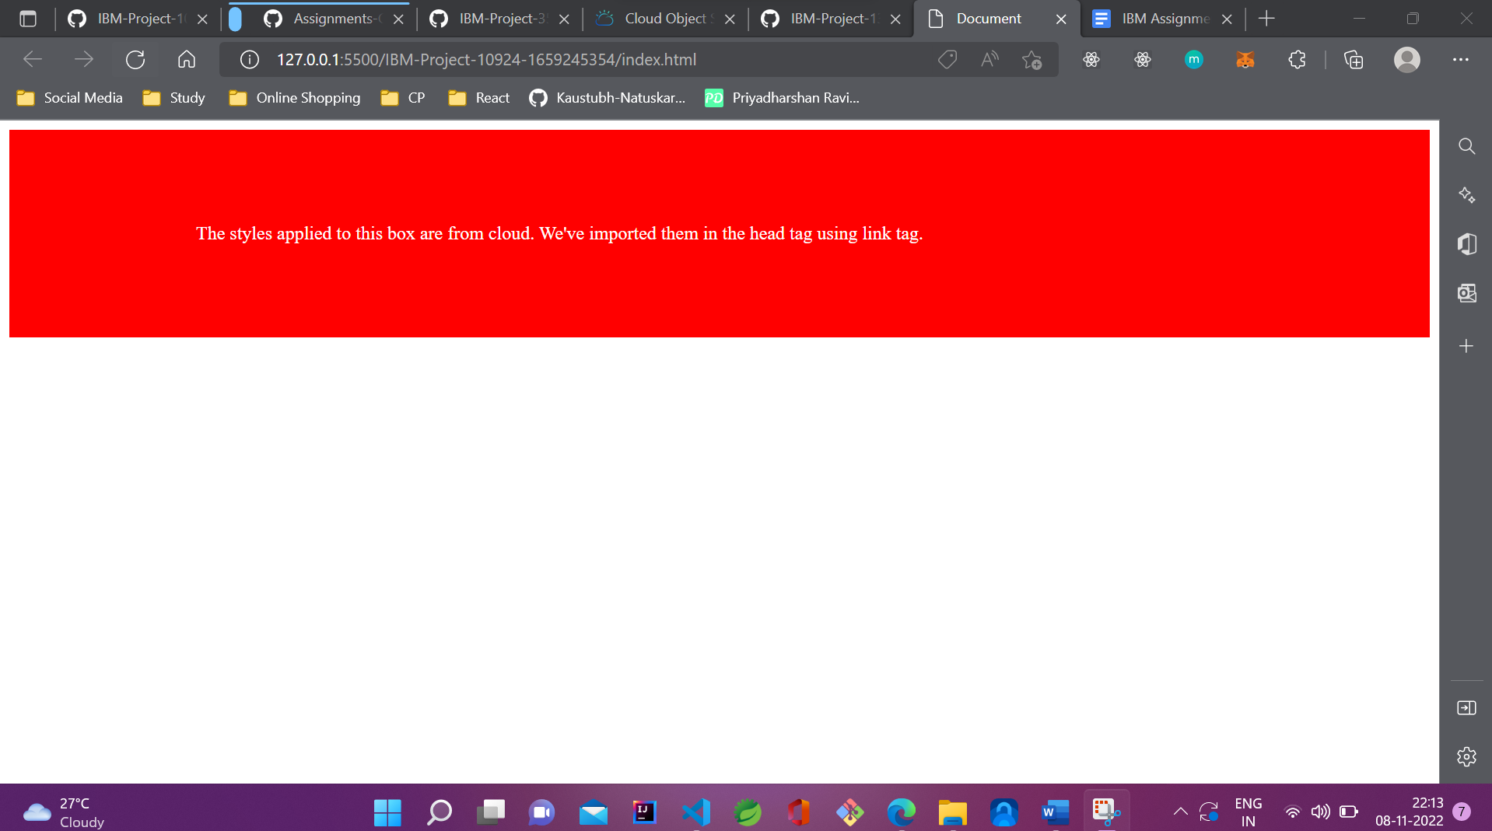

**4.Design a chatbot using IBM Watson assistant for hospitals. Ex: User comes with a query to know the branches for that hospital in your city. Submit the web URL of that chat bot as an assignment.**

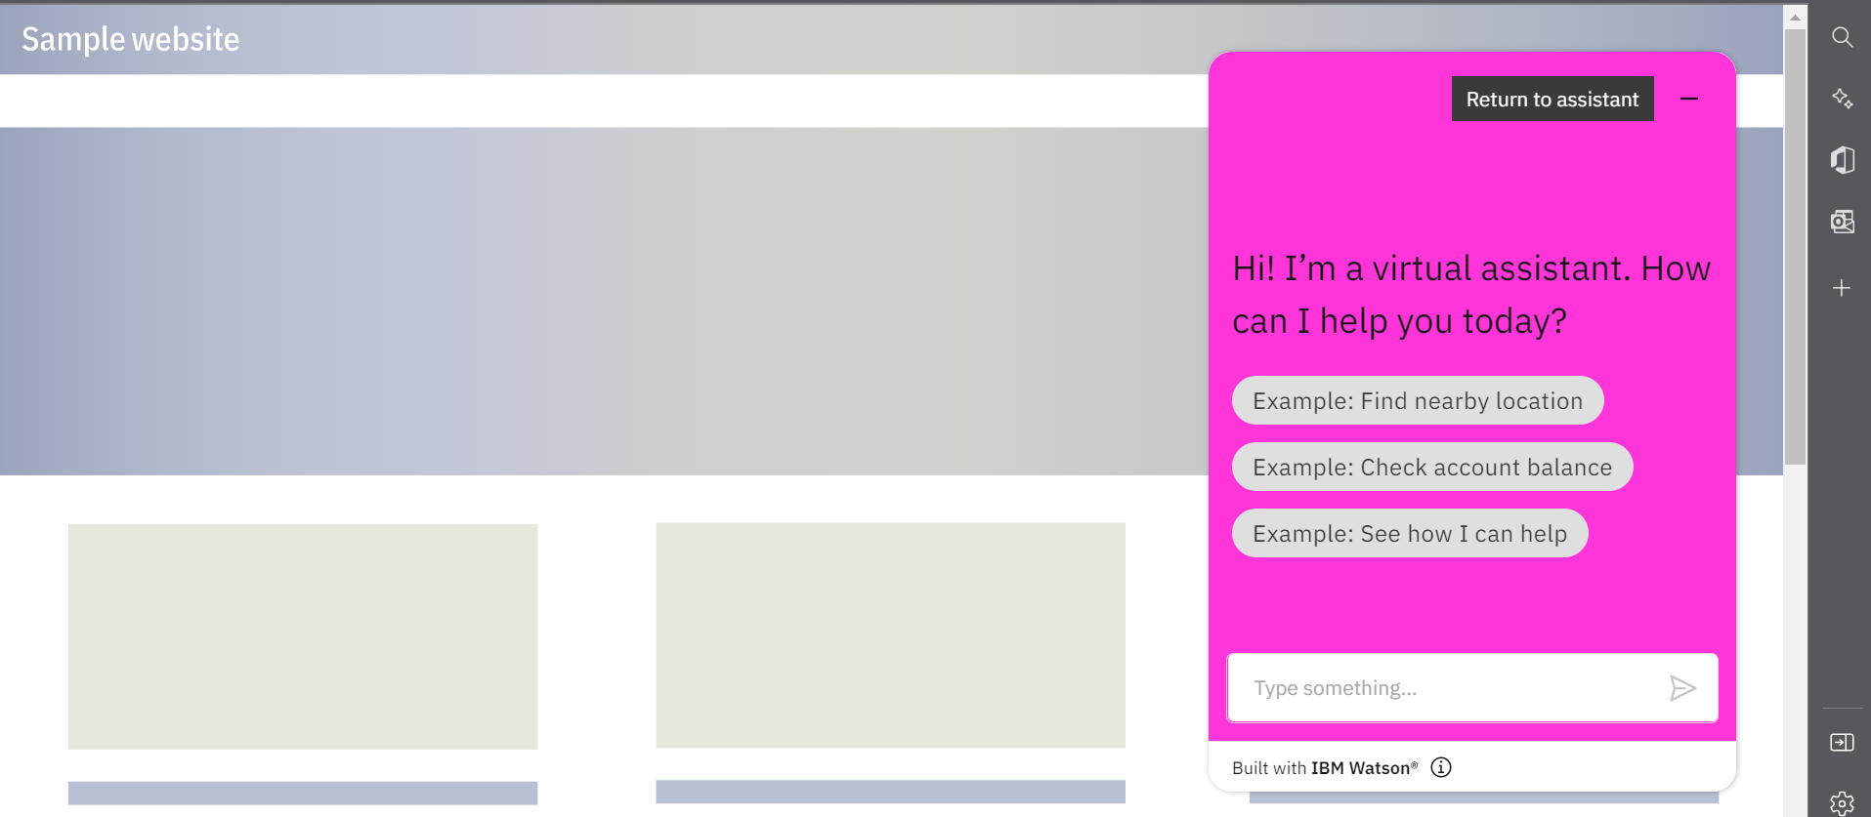

[**Chat bot Link:**](https://web-chat.global.assistant.watson.appdomain.cloud/preview.html?backgroundImageURL=https%3A%2F%2Fau-syd.assistant.watson.cloud.ibm.com%2Fpublic%2Fimages%2Fupx-b47134eb-7b1f-4d23-a9f8-d0e6b0f0d457%3A%3A78f49bd2-3e1c-47f8-8984-369487cddb39&integrationID=70bccedd-08a4-4d1d-9c5a-69b3e2d210f3&region=au-syd&serviceInstanceID=b47134eb-7b1f-4d23-a9f8-d0e6b0f0d457) [**https://web-chat.global.assistant.watson.appdomain.cloud/preview.html?backgroundImageURL=https%3A%2F%2Fau-syd.assistant.watson.cloud.ibm.com%2Fpublic%2Fimages%2Fupx-b47134eb-7b1f-4d23-a9f8-d0e6b0f0d457%3A%3A78f49bd2-3e1c-47f8-8984-369487cddb39&integrationID=70bccedd-08a4-4d1d-9c5a-69b3e2d210f3&region=au-syd&serviceInstanceID=b47134eb-7b1f-4d23-a9f8-d0e6b0f0d457**](https://web-chat.global.assistant.watson.appdomain.cloud/preview.html?backgroundImageURL=https%3A%2F%2Fau-syd.assistant.watson.cloud.ibm.com%2Fpublic%2Fimages%2Fupx-b47134eb-7b1f-4d23-a9f8-d0e6b0f0d457%3A%3A78f49bd2-3e1c-47f8-8984-369487cddb39&integrationID=70bccedd-08a4-4d1d-9c5a-69b3e2d210f3&region=au-syd&serviceInstanceID=b47134eb-7b1f-4d23-a9f8-d0e6b0f0d457)

**5.Create Watson assistant service with 10 steps and use 3 conditions in it. Load that script in the HTML page.**

**Adding 10 steps**

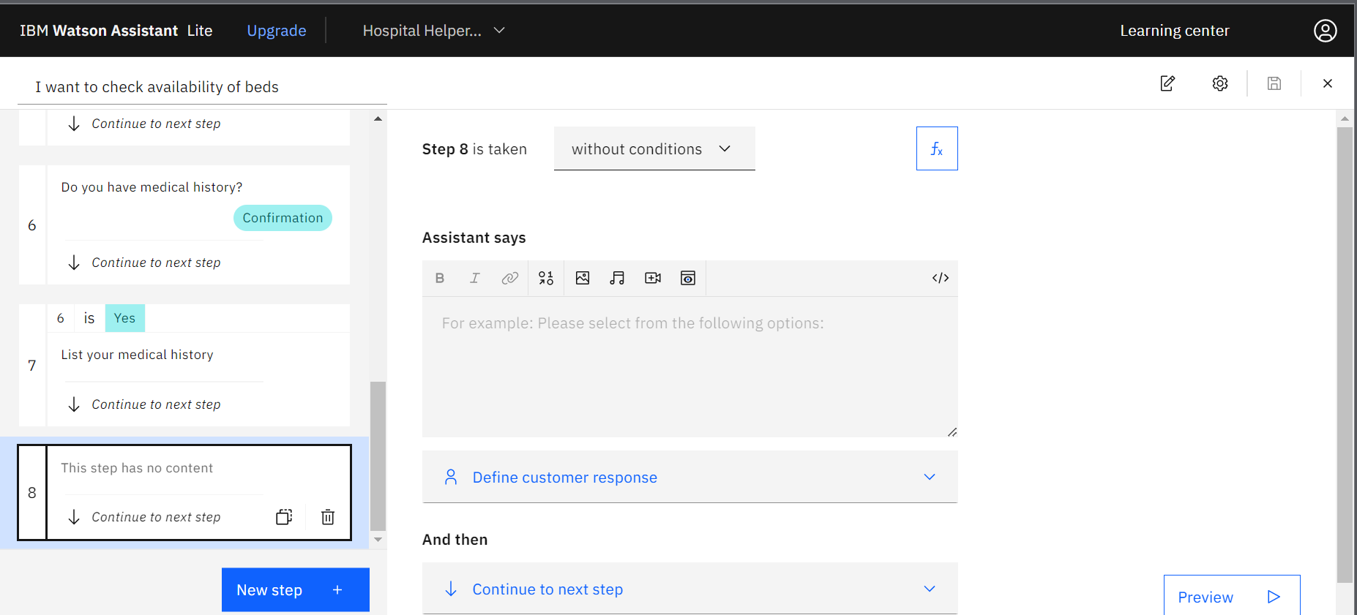

**Embedding in a website**

**<!DOCTYPE html>**

**<html lang="en">**

**<head>**

**<meta charset="UTF-8" />**

**<meta http-equiv="X-UA-Compatible" content="IE=edge" />**

**<meta name="viewport" content="width=device-width, initial-scale=1.0" />**

**<title>Embedding watson chat box in website</title>**

**</head>**

**<body>**

**<h1>Embedding watson chat box in website</div>**

**<script>**

**window.watsonAssistantChatOptions = {**

**integrationID: "70bccedd-08a4-4d1d-9c5a-69b3e2d210f3", // The ID of this integration.**

**region: "au-syd", // The region your integration is hosted in.**

**serviceInstanceID: "b47134eb-7b1f-4d23-a9f8-d0e6b0f0d457", // The ID of your service instance.**

**onLoad: function (instance) {**

**instance.render();**

**},**

**};**

**setTimeout(function () {**

**const t = document.createElement("script");**

**t.src =**

**"https://web-chat.global.assistant.watson.appdomain.cloud/versions/" +**

**(window.watsonAssistantChatOptions.clientVersion || "latest") +**

**"/WatsonAssistantChatEntry.js";**

**document.head.appendChild(t);**

**});**

**</script>**

**</body>**

**</html>**

